

**A.G. Patil Polytechnic Institute, Solapur**

ALL PROGRAMS NBA ACCREDITED

2023-2024

# A

**Synopsis Of**

**“Diploma in Computer Engineering Project”**

**On “AgriBot – A WIFI controlled multi-purpose agriculture bot for multi-crop farming using NODE MCU”**

**Guided by:**

Ms.JadageS.L

**Submitted by:**

**1**.Aabha Jahagirdar

1. Darshan Awale
2. Ganesh Pagadyakul
3. Mrunal Thamake

**Abstract:**

The "Agribot" is a pioneering solution designed to revolutionize multi-crop farming by integrating smart technology into agricultural practices. Utilizing NodeMCU, this wifi-controlled multipurpose agriculture bot empowers farmers with remote access to critical tasks, such as irrigation, pesticide spraying, and soil monitoring. The Agribot aims to enhance operational efficiency, minimize labor requirements, and enable precision agriculture through real-time data collection and analysis. With its user-friendly interface and connectivity features, the Agribot stands at the forefront of sustainable and technologically advanced farming practices, contributing to increased productivity and optimized resource utilization in the agriculture sector.

**INTRODUCTION:**

# Imagine a tireless assistant, meticulously tending to your fields, day and night. This is no longer a dream, but a reality with the introduction of our revolutionary agricultural robot. This marvel of technology is designed to transform traditional farming practices, boost efficiency, and ensure sustainable growth, offering a glimpse into the future of agriculture.

# Our robot goes beyond mere automation. It sows seeds with precision, waters saplings strategically, and sprinkles fertilizer based on real-time soil conditions. But its capabilities extend far beyond. It acts as a guardian of your soil, constantly monitoring moisture levels, pH, and temperature, providing valuable insights to optimize growth. No longer are you reliant on guesswork - data-driven decisions will be your guiding light.

# But that's not all. Our robot is also a weatherman extraordinaire, meticulously tracking rainfall in your area. This information, coupled with the soil data, paints a complete picture of your field's health, allowing you to predict potential issues and proactively adjust your strategies.

# In essence, our robot is more than just a machine; it's a partner in agricultural success. By freeing you from time-consuming tasks, it allows you to focus on the bigger picture, strategize for the future, and maximize your yield. Reduced labor costs, increased efficiency, and sustainable practices are just a few of the benefits you can reap.

# Join us on this journey into the future of farming. With our innovative agricultural robot, you can cultivate not just crops, but also a brighter, more sustainable future for agriculture.

# OBJECTIVES

Objectives for Our Agribot: Optimizing Efficiency and Sustainability

**Efficiency :**

**Reduce labor costs :** By automating sowing, watering, and fertilization, the robot should free up farmers' time for other tasks, leading to potential cost savings.

**Increase planting accuracy :** Precise seed placement can optimize plant density and maximize yield potential.

**Optimize water usage :** By monitoring soil moisture and delivering water directly to the root zone, the robot can minimize water waste and ensure efficient irrigation.

**Reduce fertilizer use :** Precise application based on real-time soil data can maximize nutrient uptake and minimize fertilizer waste, lowering costs and environmental impact.

**Sustainability :**

**Improve soil health :** Continuously monitoring soil conditions allows for proactive measures to maintain optimal pH, temperature, and organic matter levels, promoting long-term soil health.

**Reduce environmental impact :** Minimized water and fertilizer use, combined with data-driven decision-making, can contribute to a lower environmental footprint for agricultural operations.

**Increase crop yield :** Optimized planting, watering, and fertilization can lead to healthier crops and potentially higher yields, enhancing overall farm productivity.

**Improve data collection and analysis :** The robot can gather valuable data on weather, soil conditions, and crop growth, enabling farmers to make informed decisions and continuously improve their practices.

**Additional Objectives:**

**Reduce reliance on manual labor :** Especially relevant in areas facing labor shortages, the robot can address challenges in finding and retaining manual labor.

**Increase farm safety :** Automating tasks with potential risks, such as handling fertilizers or working in extreme weather conditions, can improve farm safety for workers.

**Improve data accessibility and visualization:** Provide user-friendly interfaces for farmers to visualize and analyze real-time data, facilitating informed decision-making.

Scalability and adaptability: Design the robot to be easily adaptable to different farm sizes, types of crops, and soil conditions.

# TECHNOLOGIES USED:

1. Operating System:-Microsoft Windows 10
2. Processor:-Intel Core i3(7thgen)
3. Hard disk:-4GBorabove.
4. RAM:-1GB
5. Development Tool:-Arduino IDE
6. Languages Used:-C and C++

**APPLICATIONS:**

The Agribot model finds extensive applications across agricultural scenarios, offering a transformative approach to farming practices:

1. Crop Monitoring and Health Management:

Monitor crop health through sensors and cameras, allowing early detection of diseases and optimizing interventions.

2. Multi-Crop Adaptability:

Cater to diverse crop needs by providing a customizable system that adapts to different crops and field conditions.

3. Labor Reduction and Efficiency:

Automate tasks such as irrigation and spraying, reducing manual labor requirements and improving overall operational efficiency.

4. Remote Accessibility:

Facilitate remote operation and monitoring, allowing farmers to manage their fields from anywhere, enhancing convenience and flexibility.

5. Data-Driven Decision Making:

Utilize real-time data collection and analysis for informed decision-making, optimizing resource usage and improving crop yields.

**Working:**

Let's break down the working principles of each module:

**1. Seed Sowing Module:**

- Mechanism: Employ a mechanism that dispenses seeds at regular intervals.

- Working Principle:The Agribot navigates through the field, and upon receiving the command for seed sowing, the mechanism activates to release seeds at predefined distances. This ensures even distribution across the agricultural area.

**2. Fertilizer Dispensing Module:**

- Mechanism: Use a mechanism to dispense fertilizers as the Agribot moves.

- Working Principle:When the Agribot is tasked with fertilizing, the dispensing module releases the appropriate amount of fertilizer evenly across the field. This promotes effective nutrient distribution for crop growth.

**3. Watering Module:**

- Mechanism:Implement a system for controlled water distribution.

- Working Principle:Upon receiving the watering command, the Agribot activates the watering module, releasing water through a controlled mechanism. This ensures precise and efficient watering of crops as the Agribot traverses the field.

**4. Rainwater Indicator:**

- Sensor Integration:Utilize rain sensors to detect the presence of rainwater.

- Working Principle:Rain sensors integrated into the Agribot detect the moisture levels in the soil. When rainwater is present, the indicator relays this information to the Agribot's control system, allowing it to adjust its operations accordingly. For instance, the Agribot may pause watering if sufficient rainwater is detected.

**5. Soil Condition Monitoring:**

- Sensor Integration: Incorporate soil sensors to measure moisture, temperature, and other relevant parameters.

- Working Principle:The Agribot continuously monitors soil conditions using integrated sensors. Based on the collected data, it adapts its operations. For example, if the soil is too dry, the watering module may be activated, or if the soil temperature is outside the optimal range, the Agribot can adjust its activities to mitigate potential issues.

**6.Obstacle Avoidance Module:**

Sensor Systems: Install sensors such as ultrasonic or infrared sensors to detect obstacles in the Agribot's path.

Working Principle: When the Agribot encounters an obstacle, the obstacle avoidance module receives input from sensors, prompting the Agribot to change its direction or temporarily halt its movement to avoid collisions.

# MODULES:

There are a total of six modules in the AgriBot. They are as follows :

1.The Seed Sowing Module

2. Fertilizer Dispensing Module

3. Watering Module

4. Rainwater Indicator

5. Soil Condition Monitoring

6.Obstacle Avoidance Module

**1. Seed Sowing Module:**

- Mechanism: Employ a mechanism that dispenses seeds at regular intervals.

- Working Principle:The Agribot navigates through the field, and upon receiving the command for seed sowing, the mechanism activates to release seeds at predefined distances. This ensures even distribution across the agricultural area.

**2. Fertilizer Dispensing Module:**

- Mechanism: Use a mechanism to dispense fertilizers as the Agribot moves.

- Working Principle:When the Agribot is tasked with fertilizing, the dispensing module releases the appropriate amount of fertilizer evenly across the field. This promotes effective nutrient distribution for crop growth.

**3. Watering Module:**

- Mechanism:Implement a system for controlled water distribution.

- Working Principle:Upon receiving the watering command, the Agribot activates the watering module, releasing water through a controlled mechanism. This ensures precise and efficient watering of crops as the Agribot traverses the field.

**4. Rainwater Indicator:**

- Sensor Integration:Utilize rain sensors to detect the presence of rainwater.

- Working Principle:Rain sensors integrated into the Agribot detect the moisture levels in the soil. When rainwater is present, the indicator relays this information to the Agribot's control system, allowing it to adjust its operations accordingly. For instance, the Agribot may pause watering if sufficient rainwater is detected.

**5. Soil Condition Monitoring:**

- Sensor Integration: Incorporate soil sensors to measure moisture, temperature, and other relevant parameters.

- Working Principle:The Agribot continuously monitors soil conditions using integrated sensors. Based on the collected data, it adapts its operations. For example, if the soil is too dry, the watering module may be activated, or if the soil temperature is outside the optimal range, the Agribot can adjust its activities to mitigate potential issues.

**6.Obstacle Avoidance Module:**

Sensor Systems: Install sensors such as ultrasonic or infrared sensors to detect obstacles in the Agribot's path.

Working Principle: When the Agribot encounters an obstacle, the obstacle avoidance module receives input from sensors, prompting the Agribot to change its direction or temporarily halt its movement to avoid collisions.

**Architecture Diagram**

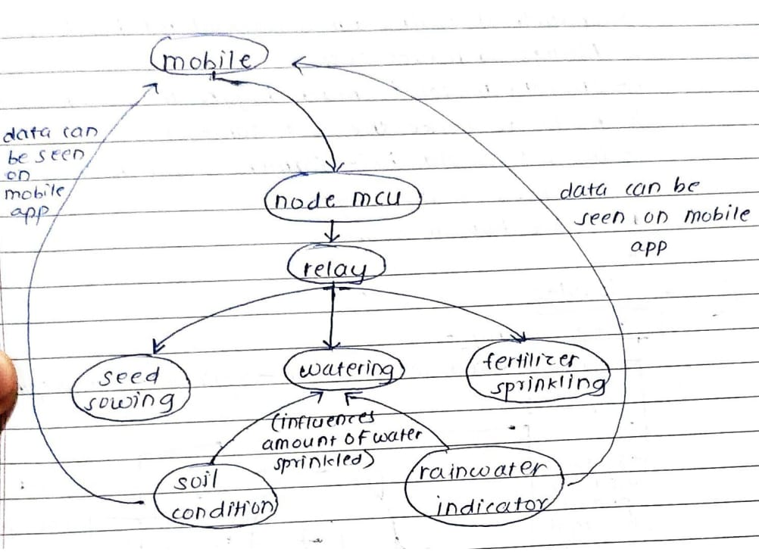

# ADVANTAGES:

**1. Enhanced Efficiency:**

- The Agribot significantly improves operational efficiency by automating key tasks such as irrigation and pesticide spraying. This leads to time savings and allows farmers to focus on more strategic aspects of crop management.

**2. Labor Savings:**

- Automation reduces the dependence on manual labor, minimizing physical strain on farmers. This value addition not only contributes to the well-being of farmers but also addresses challenges related to labor shortages in agriculture.

**3. Precision Agriculture Practices:**

- The precision irrigation and pesticide application capabilities of the Agribot contribute to precision agriculture. This leads to optimized resource usage, including water and pesticides, resulting in cost savings and environmental sustainability.

**4. Data-Driven Decision Making:**

- The Agribot provides real-time data on soil health, moisture levels, and crop conditions. This data-driven approach empowers farmers with valuable insights for making informed decisions, leading to better crop management strategies.

**5. Multi-Crop Adaptability:**

- The Agribot's ability to cater to various crops enhances its versatility and value. Farmers can utilize the same Agribot for different crops, promoting a cost-effective and adaptable solution for diverse agricultural needs.

**6. Remote Accessibility:**

- The remote control and monitoring capabilities offer farmers the flexibility to manage their fields from anywhere. This value addition provides convenience, especially for farmers with large or geographically dispersed land holdings.

**7. Improved Crop Health Management:**

- Early detection of diseases through crop health surveillance contributes to proactive management. The Agribot's ability to identify and address crop health issues in a timely manner enhances overall crop yield and quality.

**8. Resource Optimization:**

- By precisely applying water and pesticides based on real-time data, the Agribot aids in resource optimization. This not only reduces operational costs but also promotes sustainable agricultural practices by minimizing environmental impact.

**9. Technology Integration:**

- The Agribot integrates cutting-edge technologies such as NodeMCU, Wi-Fi connectivity, and sensors. This technological integration positions the project at the forefront of modern agriculture, showcasing the potential of smart farming.

# DISADVANTAGES:

1. Required Connectivity in the farming area.
2. Limited supply of water and fertilizer(refilling required).

# MAINTAINABILITY:

Modular Design :

The Agribot has a modular design that is we can break down the robot into easy replaceable modules for efficient fault identification and repair.

Standardized components :

Use readily available components to reduce spare parts inventory and simplify errors.

Accessibility:

Ensure critical components are easily accessible for inspection, maintainence and repair.

Diagnostics and troubleshooting:

Integrate onboard diagnostics and user-friendly troubleshooting tools for quick problem identification.

# FUTURESCOPE:

The future of agribot technology is brimming with exciting possibilities, promising transformative changes for the agricultural landscape. Here's a glimpse into the potential scope of your agribot:

**Advanced Capabilities:**

**AI-powered decision-making:** Robots could leverage AI to make real-time decisions on irrigation, fertilization, and pest control based on complex data analysis, optimizing yield and resource efficiency.

**Multi-tasking robots:** Imagine robots capable of performing multiple tasks simultaneously, like weeding, harvesting, and even pruning – creating a truly autonomous farm workforce.

**Livestock management:** Robots could assist with tasks like milking cows, monitoring animal health, and managing feed, improving animal welfare and farm productivity.

**Vertical farming integration:** Agribot technology could seamlessly integrate with vertical farming systems, providing automated planting, climate control, and nutrient delivery for controlled-environment agriculture.

**Precision agriculture at its finest:** Robots could become even more adept at collecting and analyzing hyper-local data, leading to ultra-precise application of resources and personalized care for each plant.

**Beyond Efficiency:**

**Labor challenges addressed:** As the agricultural workforce shrinks, robots could fill the gap, alleviating labor shortages and attracting young talent to the industry with more technical roles.

**Sustainability champion:** Agribot technology can pave the way for sustainable farming practices by minimizing water and fertilizer use, promoting soil health, and reducing the environmental impact of agriculture.

**Data-driven insights:** The vast amount of data collected by robots will fuel agricultural research and development, leading to new crop varieties, improved farming techniques, and better understanding of complex agricultural systems.

**Accessibility and affordability:** Advancements could make agribot technology more accessible and affordable for small and medium-sized farms, democratizing access to precision agriculture tools.

**Global food security:** By optimizing yields and resource usage, agribot technology could play a crucial role in addressing global food security challenges and ensuring everyone has access to nutritious food.

**Challenges and Considerations:**

**Ethical concerns:** Questions about job displacement, data privacy, and the potential for large-scale corporate control of agriculture need to be addressed ethically and responsibly.

**Infrastructure and connectivity:** Rural areas may lack the necessary infrastructure and internet connectivity to fully utilize agribot technology, requiring infrastructure development and equitable access solutions.

**Cost and affordability:** Initial investment costs for robots may be high, requiring financial solutions and support programs to make them accessible to a wider range of farmers.

**Regulatory frameworks:** Regulations need to adapt and evolve alongside the technology to ensure safe, ethical, and responsible use of agribot technology.

The future of agribot technology is bright, but it's crucial to navigate its development with foresight and responsibility. By addressing challenges and harnessing the power of collaboration, agribot technology can become a key driver for a more sustainable, efficient, and equitable future of agriculture.

**CONCLUSION**:

Cultivating a Brighter Future with Agribot Technology.

The innovative agribot stands as a testament to the transformative potential of technology in agriculture. By automating tedious tasks, optimizing resource utilization, and gathering valuable data, it offers a glimpse into a future where farming is more efficient, sustainable, and data-driven.

The implications of your agribot extend far beyond the field. It has the potential to address labor shortages, promote environmental responsibility, and contribute to global food security. With continued development and responsible implementation, it can be a powerful tool for empowering farmers, fostering innovation, and ensuring a brighter future for agriculture.

However, the journey doesn't end here. As you move forward, remember to consider the ethical considerations, infrastructure challenges, and affordability concerns associated with this technology. By proactively addressing these issues and collaborating with stakeholders across the agricultural ecosystem, you can ensure that your agribot technology not only revolutionizes farming practices but also does so in a way that is inclusive, equitable, and sustainable.

The future of agriculture is brimming with possibilities, and your agribot is at the forefront of this exciting transformation. Remember, the seeds you sow today will blossom into a more productive, sustainable, and resilient agricultural landscape for generations to come.